MP Survey Completion Evidence

[Screenshot your MP Survey Completion Page and paste it here.]

Declaration of Originality

I am the originator of this work and I have appropriately acknowledged all other original sources used as my references for this work.
I understand that Plagiarism is the act of taking and using the whole or any part of another person‘s work, including work generated by AI, and presenting it as my own.
I understand that Plagiarism is an academic offence
and if I am found to have committed or abetted the offence of plagiarism in relation to this submitted work, disciplinary action will be enforced.

Students‘ Signatures: ____________________

____________________

____________________

Declaration on the use of Generative AI tools for projects
Describe how you have used Generative AI tools such as ChatGPT or Dall.E- in your assignment.
Share the link to the conversations you had with the AI tool (i.e., the prompts you used and the responses you get from the AI tool).
How do you indicate the reference?
The content generated by AI tools are not retrievable except by the user who generated them, so they are considered non-recoverable sources. Although non-recoverable data or quotations in APA Style papers are usually cited as personal communications, with ChatGPT-generated text there is no person communicating. Quoting text from ChatGPT chat is therefore more like sharing the output of an algorithm, with a reference list entry and the corresponding in-text citation.
According to the official APA Style site, ChatGPT references should be cited as: E.g. OpenAI. (2024). ChatGPT (Feb 13 version) [Large language model].
https://chat.openai.com/chat

Note: The information in parentheses refers to the update or revision date of
the model used. Refer to the release notes in the ChatGPT application.

Important Note:
- Do not copy answers produced by the AI tool in totality as it is considered as plagiarism.
- Do not rely on any information produced by the AI tool blindly. You should always verify the answer with other sources. Do not assume that these answers provided by the AI tool are correct.
- To achieve quality outputs from the AI tool, you should provide good prompt that is clear and specific. Be precise and provide context. Avoid asking open-ended questions.

Top margin= 2.54cm or 1 inch

Colour Reader for the Blind

TITLE: Times New Roman (TNR), 20pts

Daniel Tan Xin Ru

Supervisor: Ms Tay Sioh Hoong
2 x Double-spacing before Abstract

Abstract
STUDENT’S NAMES: TNR, 16 pts SUPERVISOR(S): TNR, 14 pts
ALL: Bold, Title Case Double-line spacing, Centre-justification

ABSTRACT: TNR. 12 points,
Bold + Title Case for Heading; Normal + Sentence case for text, italics, Single-line spacing

This project aimed to design and fabricate a highly reliable and user-friendly electronic device to enable the vision-impaired people to perform basic colour recognition tasks. Photodiodes were used to identify the colour of the targeted surface and a voice-recording chip would clearly output the detected colour in the form of pre-synthesized voice. A total of ten different colours could be recognized. While the objectives of the project were successfully achieved, using an ISD4003 voice-recording chip would increase the number of recorded colours.

INTRODUCTION
HEADINGS: TNR. 12 points, Bold, UPPERCASE, Align Left

  - Background
Sub-Headings: TNR. 12 points, Bold, Title Case, Align Left


The world is full of colour. Colour is what gives objects their physique and beauty. It plays an important role in our life. Many applications were related to colours such as fashion designs, warning signs, spor mpaired,
ts, etc. For the blind or vision-i
Citation number corresponds with Reference #1

Left & Right margin= 2.54cm or 1 inch
recognition of colour is
a challenge [1]. The blind or vision-impaired often have


difficulty in telling the colour of an object in basic day-to-day activities such as choosing clothes or selecting shoes. The Colour Reader for the Blind could contribute to their independence, as it assists them in the course of daily activities.
Page number in bottom margin (centre or right) in footer, TNR, 10 pts, Normal

1
Bottom margin=2.54cm or 1inch

Objectives

The aim of the project was to design a prototype of a colour-detecting device that automatically reads the colour of the targeted surface. It must be able to detect at least six colours. The device should be ergonomically designed, low cost, portable, highly reliable in terms of colour reading and user-friendly. Its weight should not
exceed 700 grams.
Objectives are clearly written, starting with the broad aim/objective, and then followed by specific objectives, listed in bullet points, each beginning with an action verb.
2 x Double-spacing before new paragraph
The specific technical objectives were to:

- program a PIC18F4520 microcontroller to control the operation of the device.

- enable announcements of the detected colour using a voice-recording chip.

- power the device with the use of 9V batteries.
2 x Double-spacing before new paragraph

PROJECT DESCRIPTION

  - Physical Description of the Colour Reader Device

The colour reader device has a width of 170mm, length of 210mm and height of 40mm, weighs less than 700 grams and has a gun-like casing as shown in Figure 1 and 2 with a processing circuit inside it. … … …

Processing Circuit

The processing circuit consists of six modules: the photodiodes and white Light Emitting Diode (LED) as shown in Figure 1. The photodiodes …
Note how this subsection is indented 0.5” from the margin. This applies to both the sub- heading and the text.
2
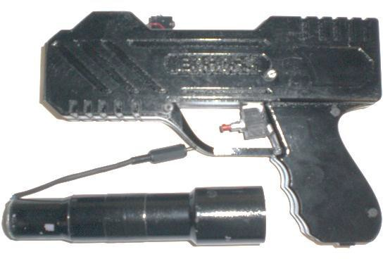

Photodiodes and white LED module
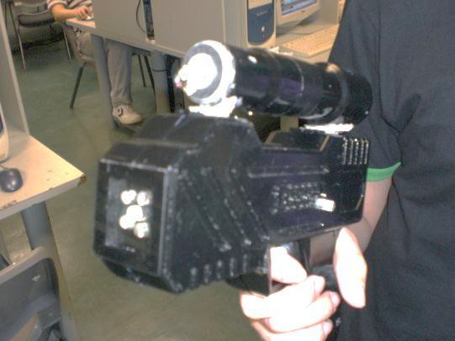
Volume adjustment switch
Speaker connector

On/off switch

Screws

Speaker

Figure 1 Front view of the Colour Reader device Figure 2 Side view of Colour Reader device
All figures are numbered, captioned & clearly labeled (TNR 10pts)
The left side of the colour reader device has a volume control switch (see Figure 1) that has five adjustable volumes for the read-out of the detected colour.
The device has an external 1.5watt-rating speaker as an accessory that is installed by connecting it to the speaker connector as shown in Figure 2. A push-button switch seen in Figure 2 is located at the trigger area of the gun-liked casing to turn on or turn off the device.
2 x Double-spacing before new paragraph

Process Description

To detect the colour of a surface, the targeted surface is illuminated with white light and the reflected light intensity is converted into current by a photodiode.[2] The output current of the photodiode is then amplified to a suitable voltage using a Current-to-Voltage (C-V) converter. An Analog-to-Digital Converter (ADC) …

3
Layout Tips:
- If there is insufficient space at the end of a page, do NOT begin a new section, especially if there is only enough space for just the heading/sub-heading. NEVER leave a “hanging” heading, without any text. It is sloppy.
- On the other hand, DO NOT LEAVE large white spaces, without text, as this interrupts the flow for the reader and looks unfinished.

PRODUCT DEVELOPMENT (or METHODOLOGY)
……

RESULTS
…….

CONCLUSION
……..

====

Acknowledgments
The author wishes to thank Ms Tay Sioh Hoong (Major Project Supervisor) for her patience and help, and all the staff from the TES component store for their helpful advice and service.
HEADINGS: TNR. 12 points, Bold, Title Case, Align Left TEXT: TNR, 12 points, Normal, Sentence case.

References Works Cited
- The Wikipedia Site. (2008). Spectral colours. [Online] Available: http://en.wikipedia.org/wiki/Colour
lling Machine – The MDX-40. [Online] Available: ducts/milling/

[2] The Rolanddga Site. (2004). Mi  http://www.rolanddga.com/asd/pro | REFERENCES: Use required IEEE style & be accurate, including all punctuation. Note that the writer has organised references by specific “Works Cited” and the more general “Other Sources” (sequence this list alphabetically by author’s surname or company name).  Use HEADINGS: TNR. 12 points, Bold, Title Case, Align Left. TEXT: TNR, 12 points, Normal, Sentence case
Other Sources
T. L. Floyd. (2005). Electronics Devices, 7th ed. New Jersey USA : Prentice Hall Inc.
National Semiconductor. (2008). LM7905 -3- Terminal Negative Regulator. [Online] Available: http://www.national.com/mpf/LM/LM7905.html
R. T. Paynter. (2003). Introductory Electronic Devices and Circuits, 7th ed. New Jersey USA: Prentice Hall Inc.
STMicroelectronics. (2003). Test and Application Circuits. [Online] Available: http://matthieu.benoit.free.fr/cross/data_sheets/TBA820M.pdf
D. L. Terrel. Op-Amps Design, Application, and Troubleshooting, Prentice-Hall, 1992
The Farnell Site. (2000). Characteristic of LM10CLN Op-Amp. [Online] Available: http://www.farnell.com/datasheets/64239.pdf

Left & Right margin= 2.54cm or 1 inch

Appendices
Appendix A: Schematic diagrams and PCB Layout Appendix B: Block Diagram
APPENDICES:. Use the modular way (A, B, C…) of labelling instead of numbering; there is no pagination. The last one should be “Poster & Flyer”. HEADINGS: TNR. 12 points, Bold, Title Case, Align Left.
TEXT: TNR, 12 points, Normal, Sentence case
Appendix C: Program Codes Appendix D: Final Prototype Appendix E: Datasheets
Appendix F: Manual of Voice Record/Playback Module Appendix G: Project Poster and Flyer
Page number in bottom margin (centre or right) in footer, TNR, 10 pts, Normal

10
Bottom margin=2.54cm or 1inch

